Breakpoint When Hit
This is apart from your normal debug steps, you want to do something else while breakpoint is hit, like print a message or run some macros. For those type of scenarios, you may go for this option. You can open this window by just right clicking on breakpoint.
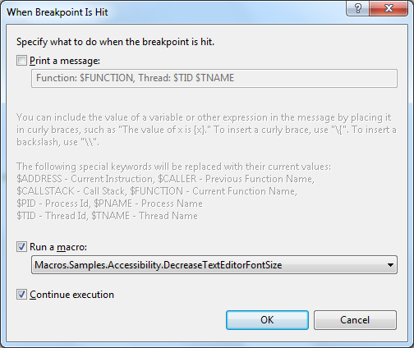

The first thing that you need to notice is the symbol of breakpoint. Breakpoint symbol has changed to a diamond and you can also check out the tool tip message which indicates what it is going to do when execution reaches here.
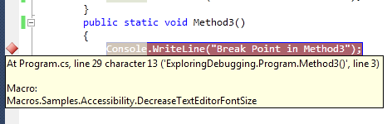
Figure: When Breakpoint Is Hit

#include<iostream>
using namespace std;
int main()
{
int i=0;
int cnt=0;
int a=10;

while(i<10)
{
i++;
cout<<i<<endl;
}

return 0;
}

Specify hit count as “ when hit count reaches to multiples of 3”
Specify when hit as “print “hello world” “ message

Press F5 and check
“hello world” output will come 3 times

